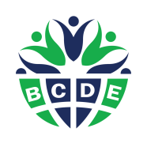
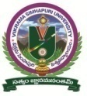
VIKRAMA SIMHAPURI UNIVERSITY
NELLORE – 524324

BCDE Activities Report 2024 -2025

Brief Report on Awareness Project – “Prevention of Dengue”

Board for Community Development through Education, Govt. of AP, informed the University Authorities to direct all the College Administration to instruct BCDE Soldiers (Students) to take up the Awareness Project – Prevention of Dengue. Each BCDE Soldier /Student of Higher Education conduct awareness campaign to reach a minimum of 50 citizens in and around his/her area of residence/study to prevent DENGUE.
In this context, University authorities informed all the Principals to instruct the BCDE College Coordinators/CSP Mentors to see that more number of students conduct awareness programs on Prevention of Dengue.
In this regard, Dengue prevention activities conducted by the colleges under the jurisdiction of Vikrama Simhapuri University, Nellore are given below.
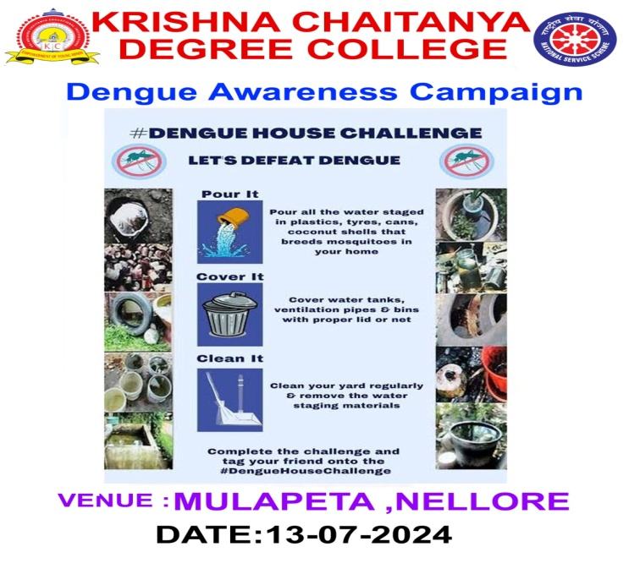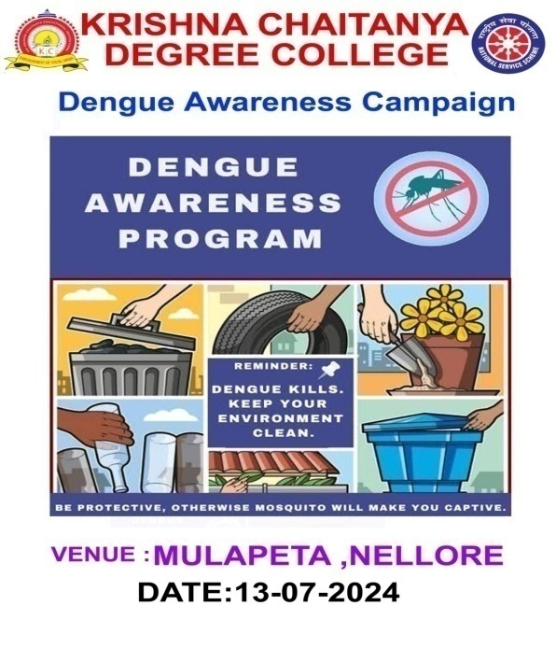
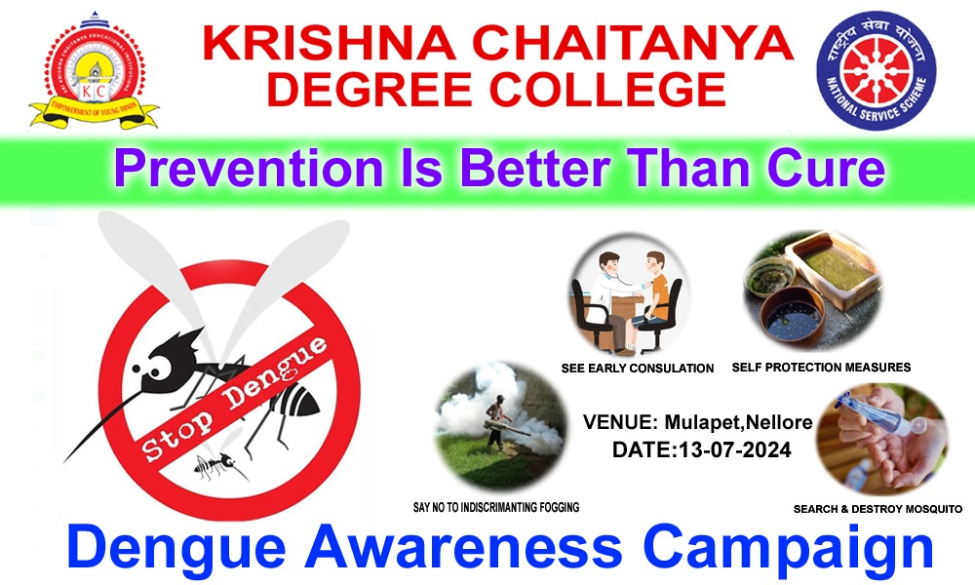

BCDE College Coordinator giving awareness to the Students
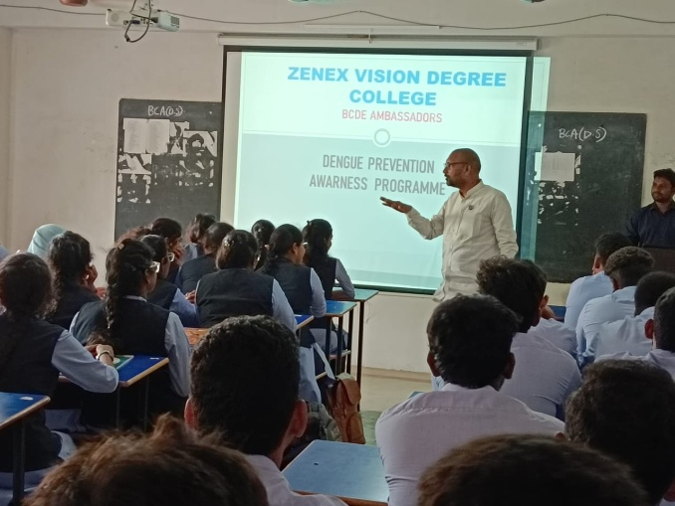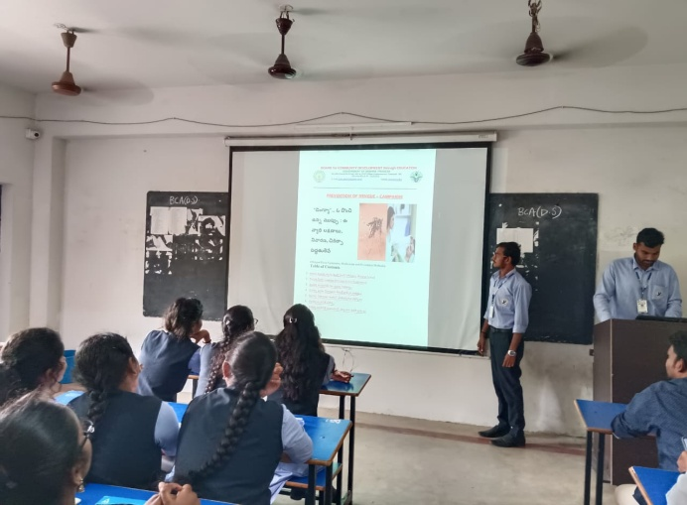

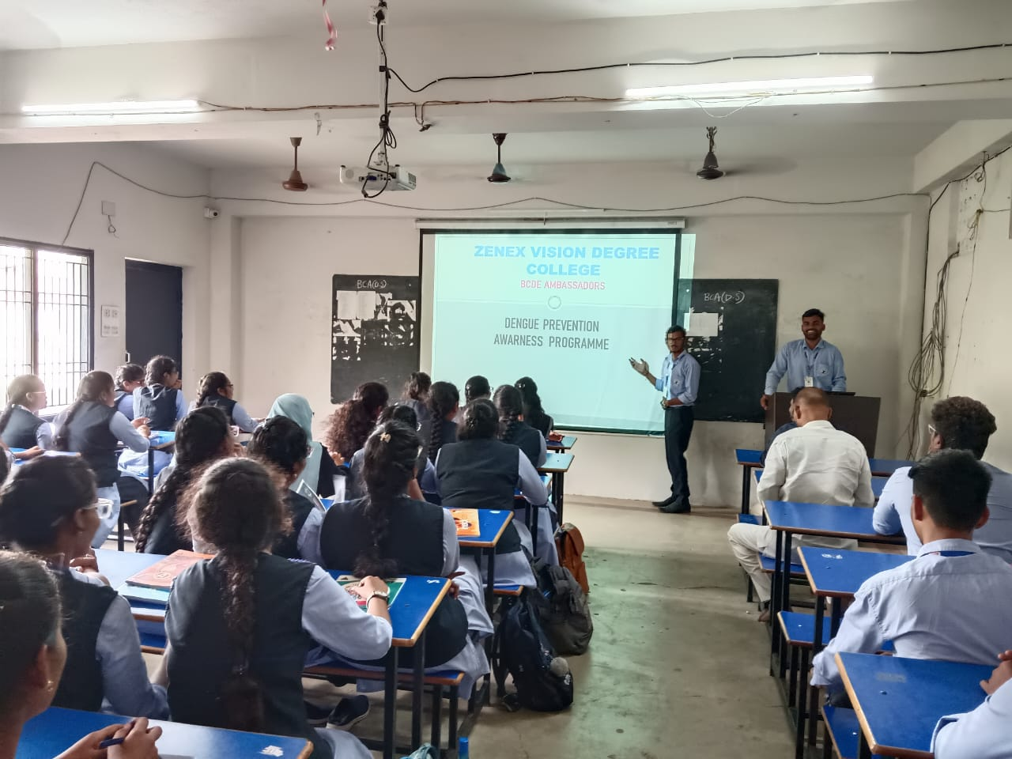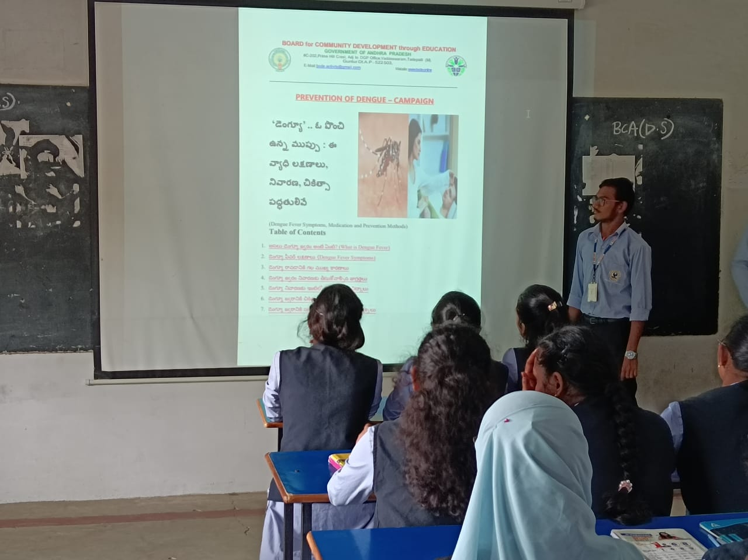
BCDE Soldiers conducted awareness campaign in nearby area.
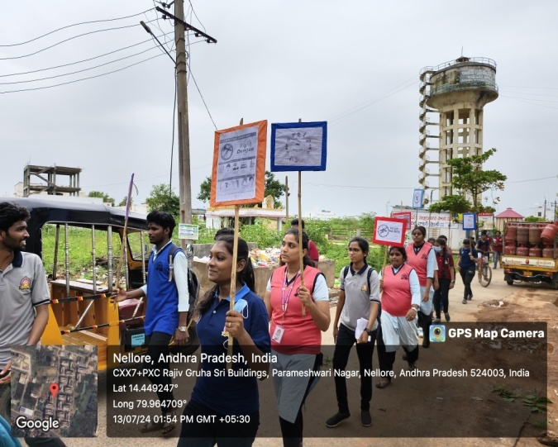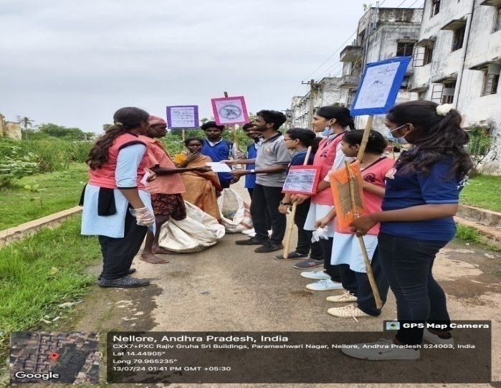

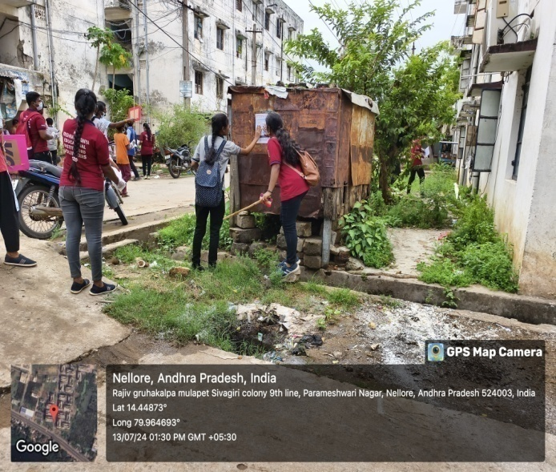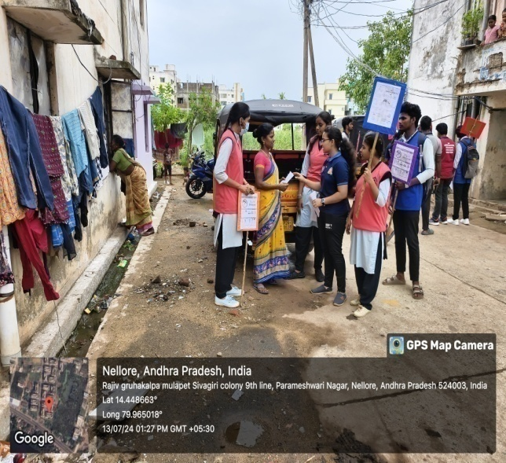
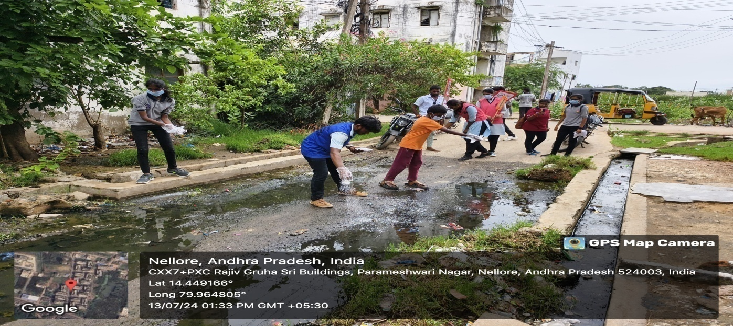

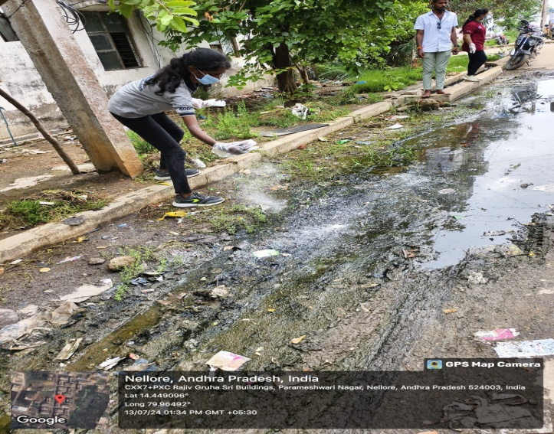

Conducted Dengue Awareness Program among the students and Staff Members
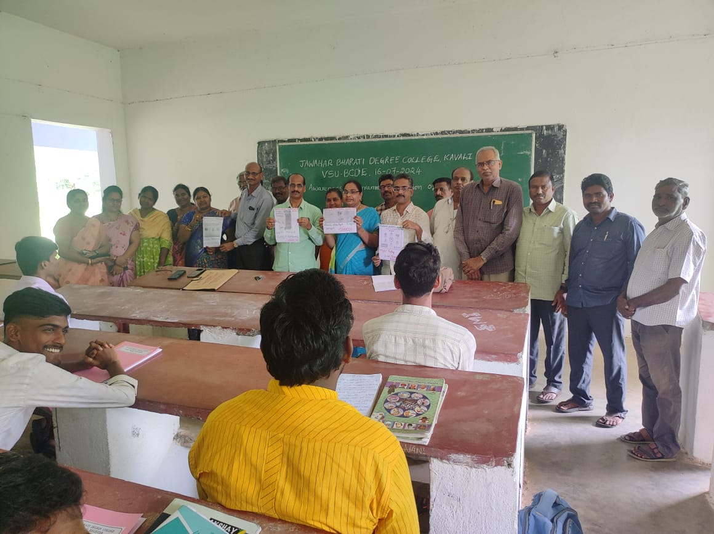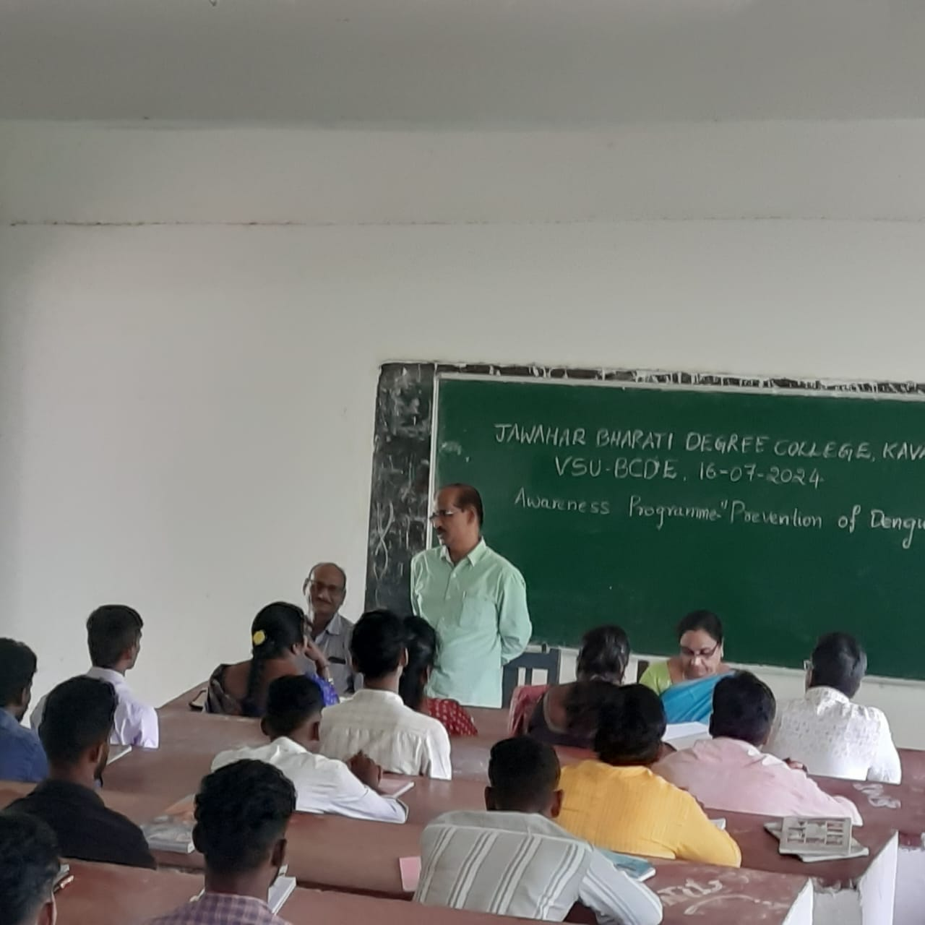
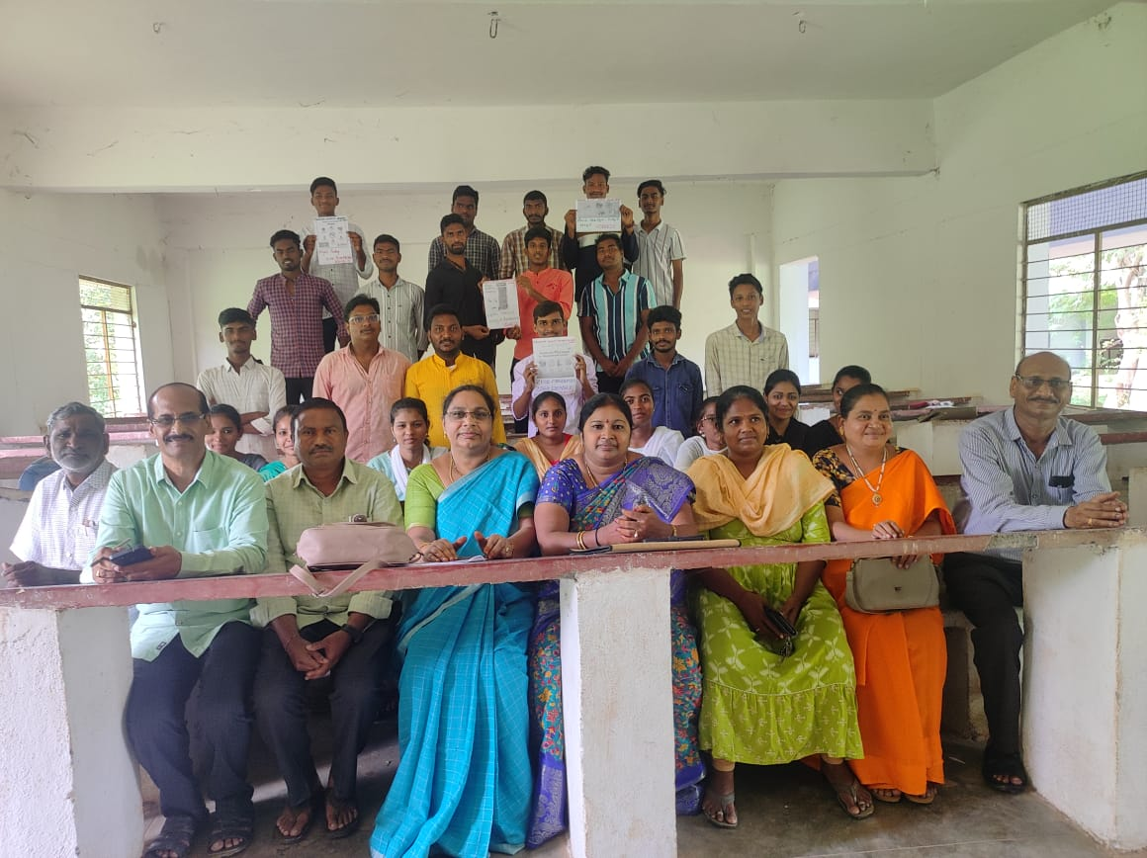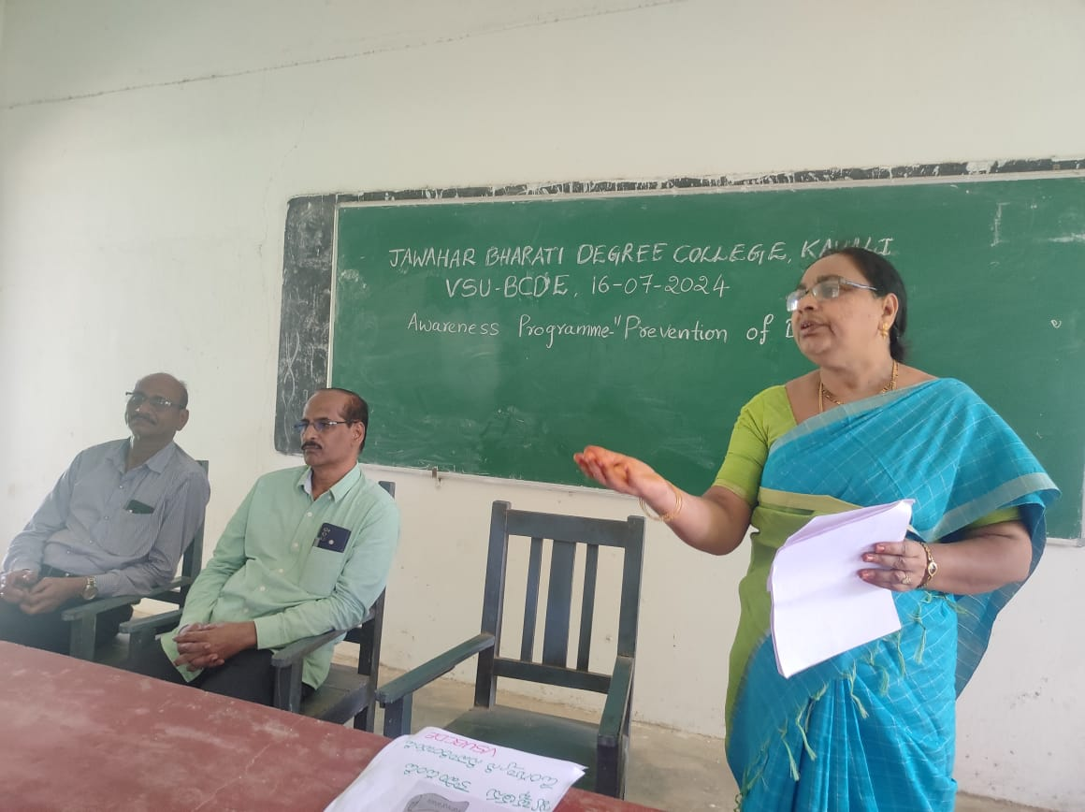
Press Clippings
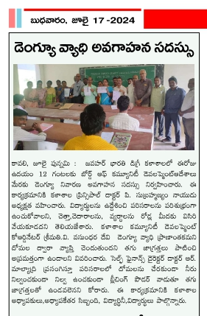

A BRIEF REPORT on
“One Day Orientation Session on Learning Improvement Program”
Held on 19th April 2024 at Vikrama Simhapuri University, Nellore

Vikrama Simhapuri University (VSU), Nellore, Andhra Pradesh State Council of Higher Education (APSCHE), Board for Community Development (BCDE), United Nations International Children's Emergency Fund (UNICEF), Samagra Shikshan, Sikshana foundation and Save the Children Jointly organized one day orientation session on Learning Improvement program (LIP) at Sir C.V Raman seminar hall, Vikrama Simhapuri University, Nellore on 19th April 2024 for BCDE college coordinators and community service project mentors of affiliated colleges under the jurisdiction of Vikrama Simhapuri University, Nellore and Jawaharlal Nehru Technological University (JNTU), Anantapur. Sixty BCDE College coordinators and CSP mentors from various affiliated colleges of VSU and JNTU-A attended to this one day orientation session. The inaugural program was started at 10.30 am. As a part of the inaugural program, University Community Development Coordinator Smt A. Jyotsna welcomed the all the dignitaries and participants and explained the objectives of the program. Later, Prof. Ch. Vijaya, dean (CDC) and president of the orientation session has shared the origin or circumstance that lead to the initiation of learning improvement program as part of the presidential remarks. Further Prof. Ch. Vijaya explained at length on various activities and programs on Learning Improvement program (LIP) conducted under the banner of VSU-BCDE. The state government universities of Andhra Pradesh state implemented learning improvement program as community service project or short term internship by students of degree colleges. As a part of this, Prof. G.M Sundaravalli honorable vice-chancellor of VSU directed all the principles and BCDE coordinators of affiliated colleges to ensure maximum enrollment and participation of students in the learning improvement program, a flagship program of Andhra Pradesh government. Prof. P. Ramachandra Reddy, Registrar of VSU stated that imparting the education through play way method right from the childhood not only enable children to acquire analytical skill but also supports or favors personality development. With this motto, UNICEF, APSCHE, BCDE Samagra siksha, Sikshana foundation and save the children have joined hands to develop innovative learning improvement program, said Registrar. Further the Registrar heaped praises on the stakeholders of LIP to bring phenomenal changes in the students of Andhra Pradesh. The unveiling of “PRERANA MITRA” booklet by guest on the dais was done before the commencement of technical sessions. The details of technical sessions given below.

1 | 11:30 am to 11:45 am | Objectives and approach of the LIP collaboration between school education and higher education departments | Smt. P.Swathi, Consultant, UNICEF
2 | 12:00 pm to 1:00 pm | Demonstration of Prerana Mitra App, Sharing the experiences of Prena Program (Sharing of app and manual) | Sri R. Appa Rao  Operations manager, Sikshana Foundation.
3. | 2:00 pm to 3:30 pm | Interactive session on BCDE activities/LIP | Smt. P.Swathi & Sri Sri R. Appa Rao
4 | 3:45 pm to 4:00 Pm | Prerana Mitra Karadeepika Manual Distribution

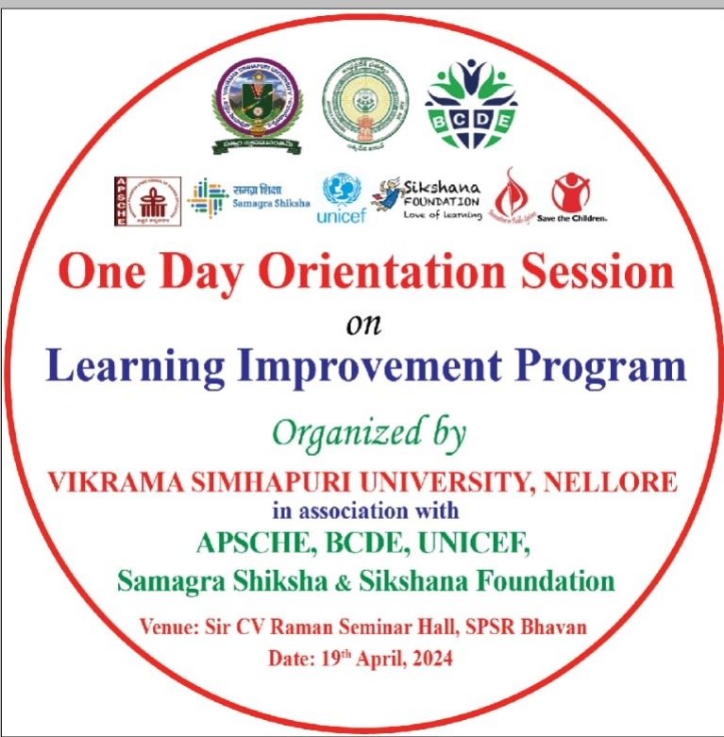
Banner

Activity Photos
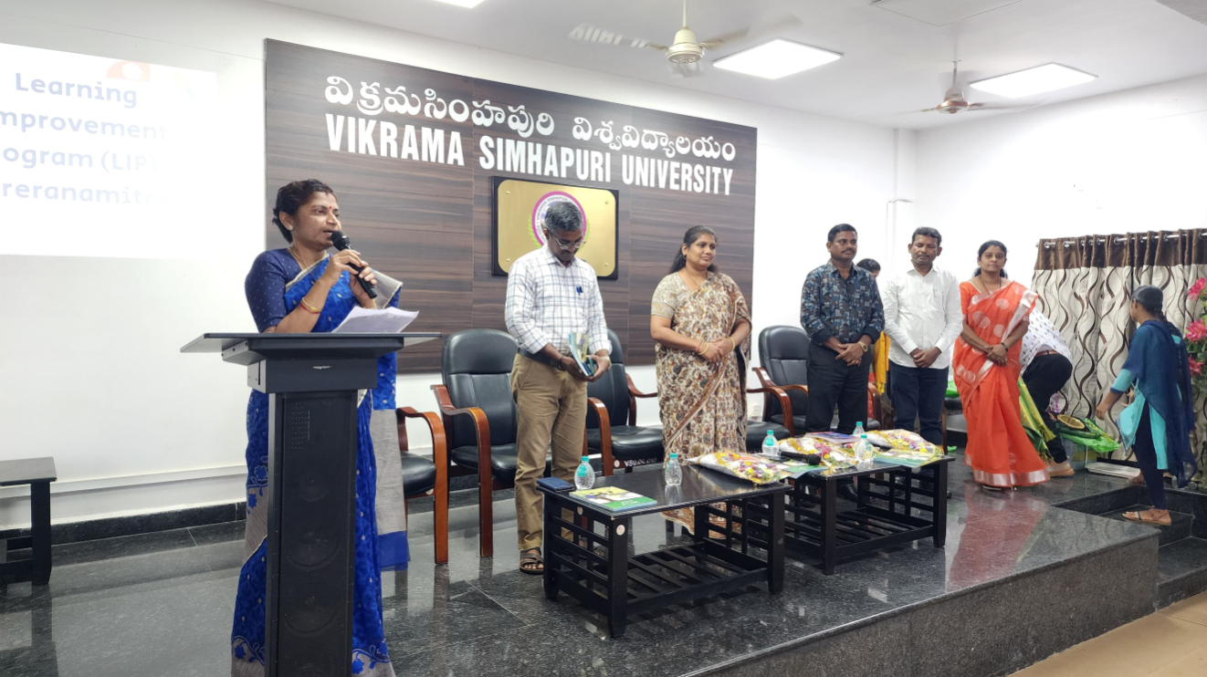
Opening Remarks by Prof.Ch. Vijaya, Dean (CDC)

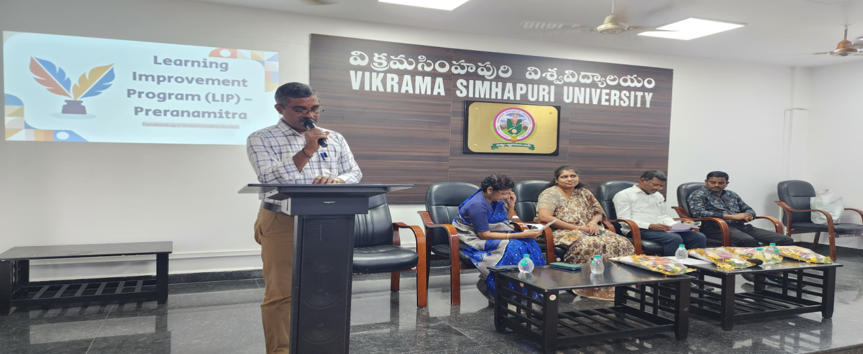
Address by Prof. P. Ramachandra Reddy, Registrar, VSU

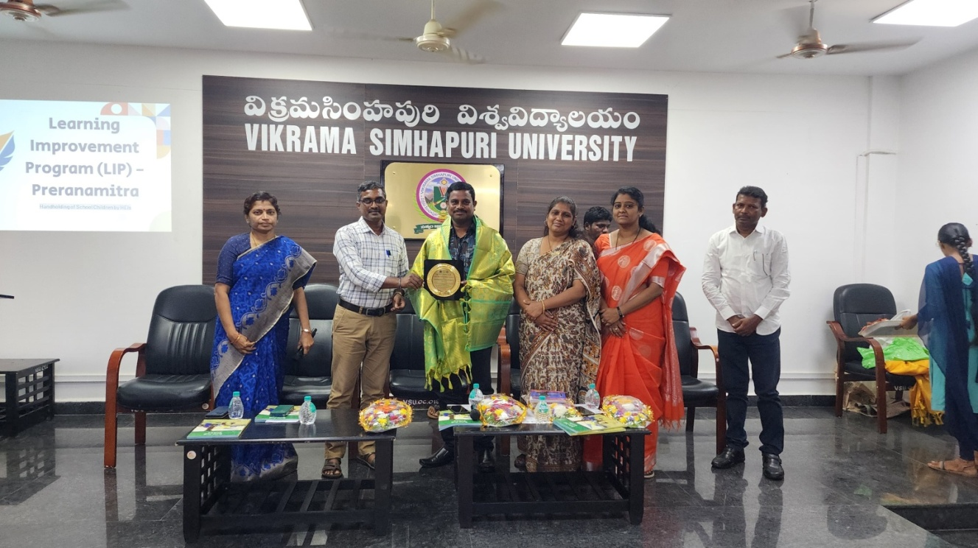
Felicitation of Sri R. Appa Rao, Operations manager, Sikshana Foundation

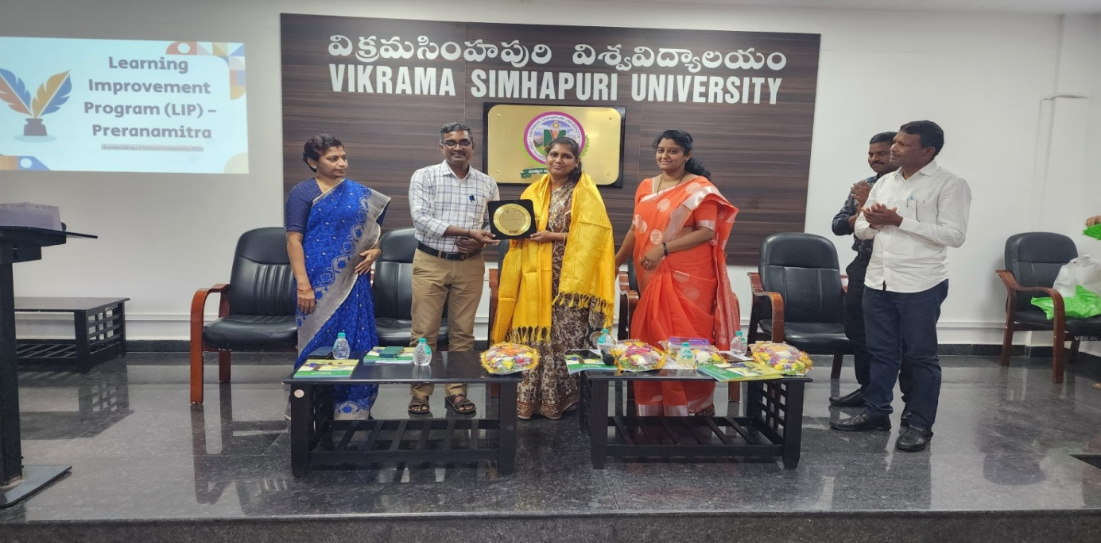
Felicitation of Smt. P. Swathi, Consultant, UNICEF

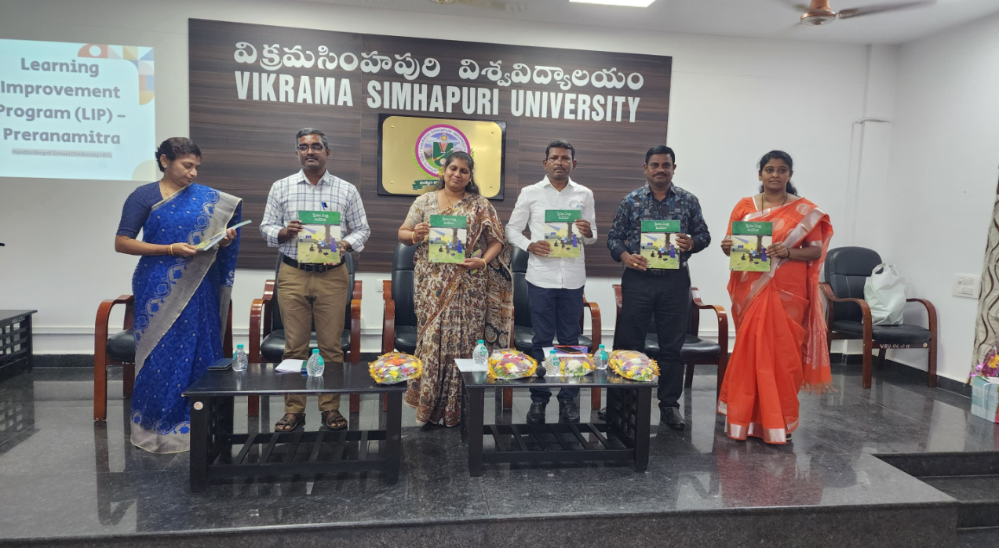
Unveiling of “PRENA MITRA” booklet by guest on the dais

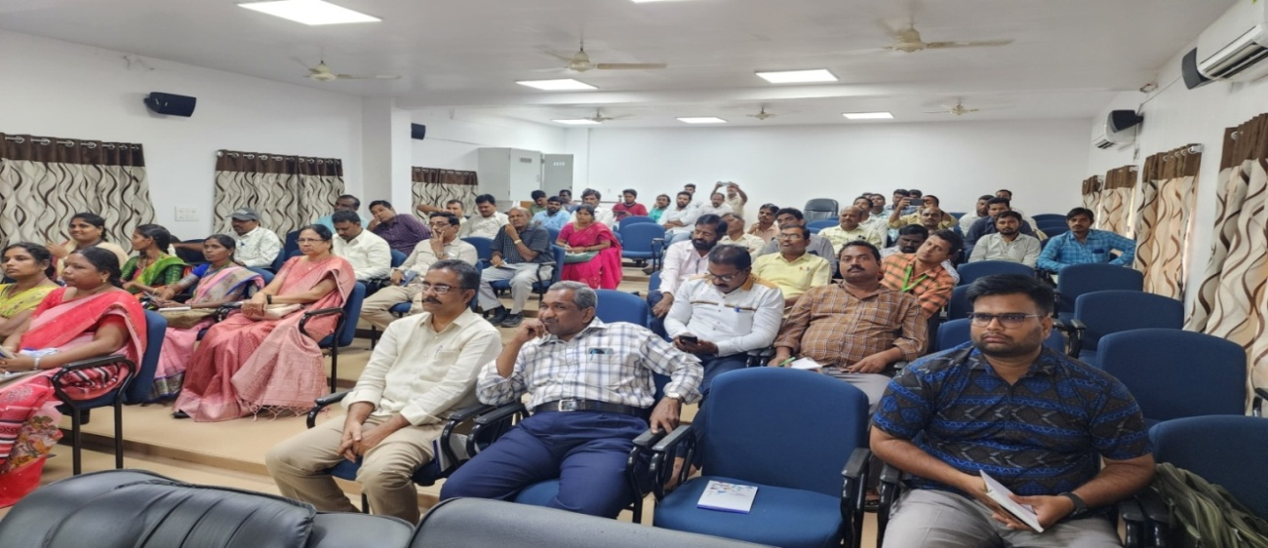
Sixty BCDE college coordinators and CSP mentors of affiliated colleges Participated

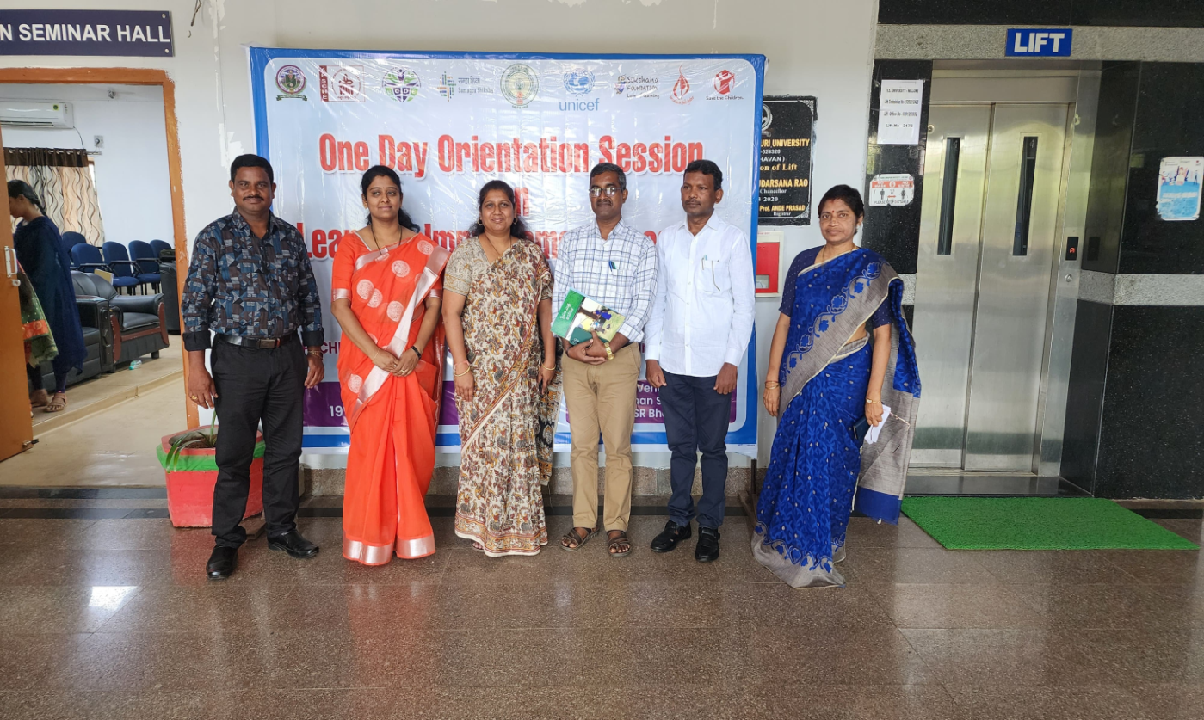
Group Photo of the Delegates

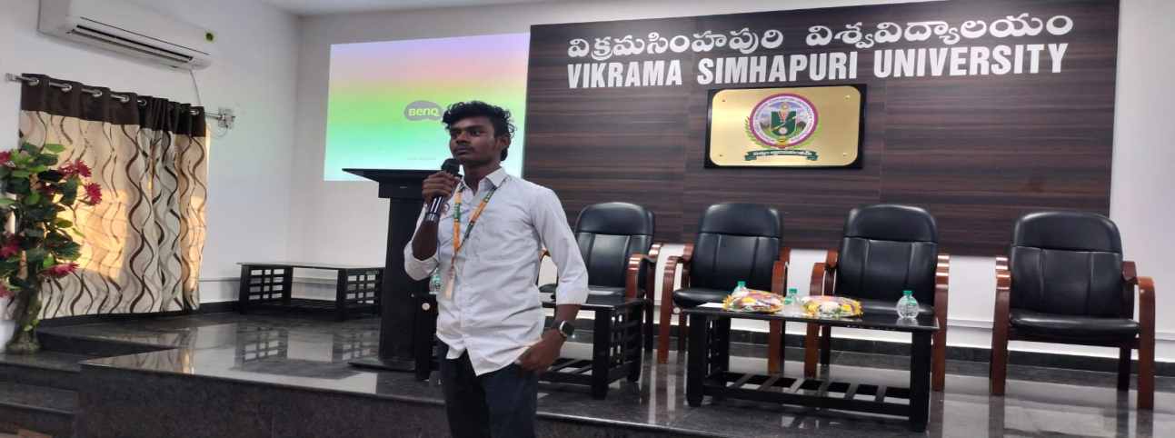
Participants feed back

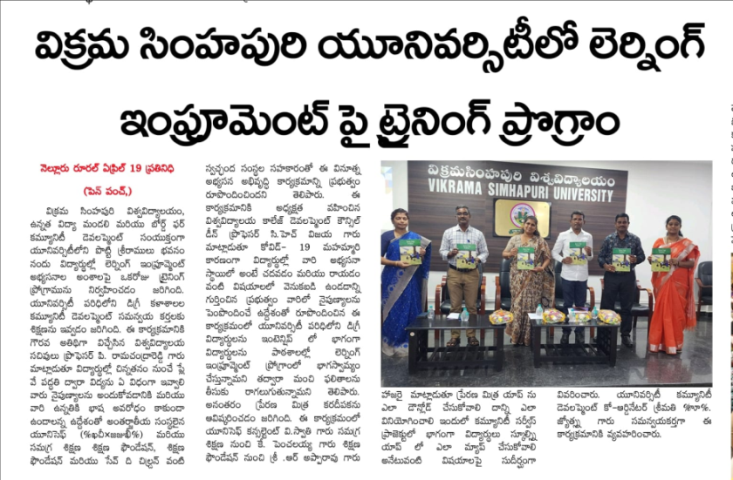
Coverage in local Daily News Papers

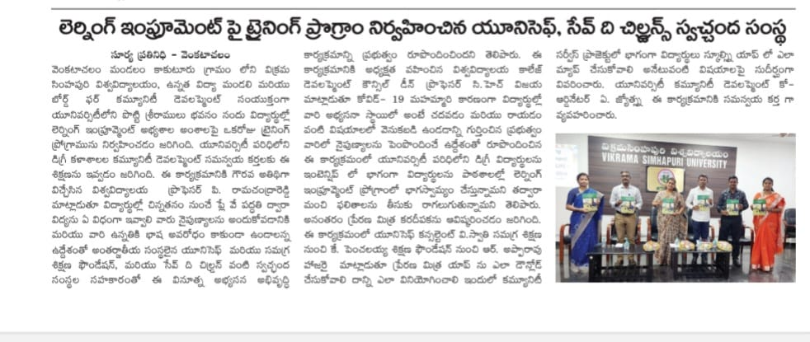

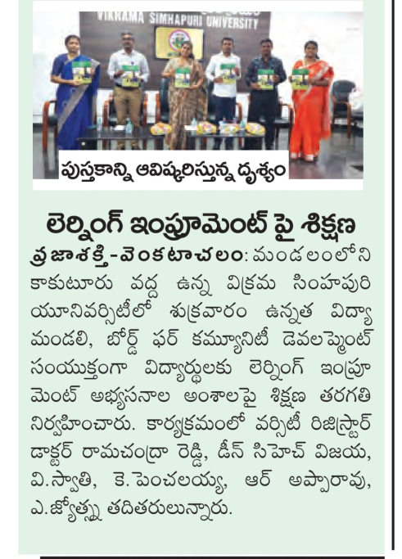
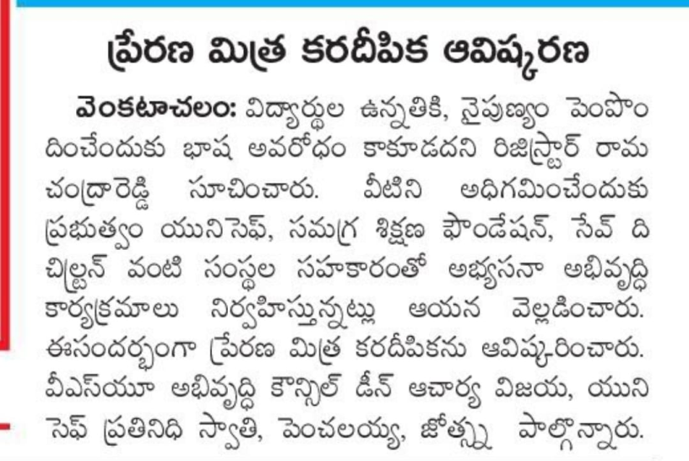

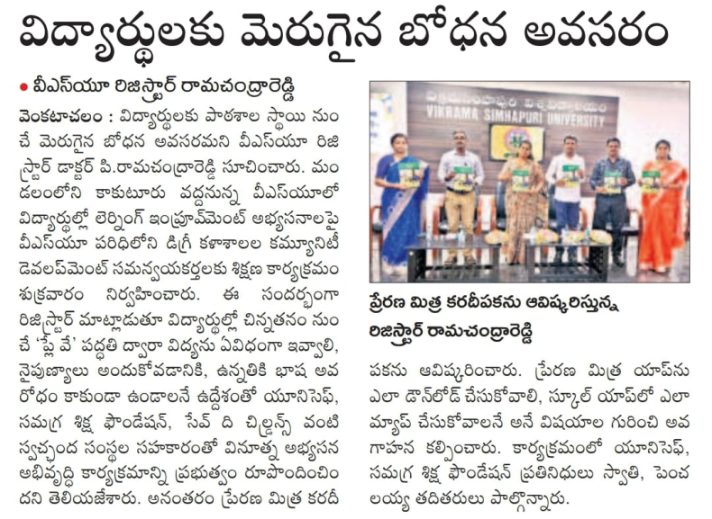

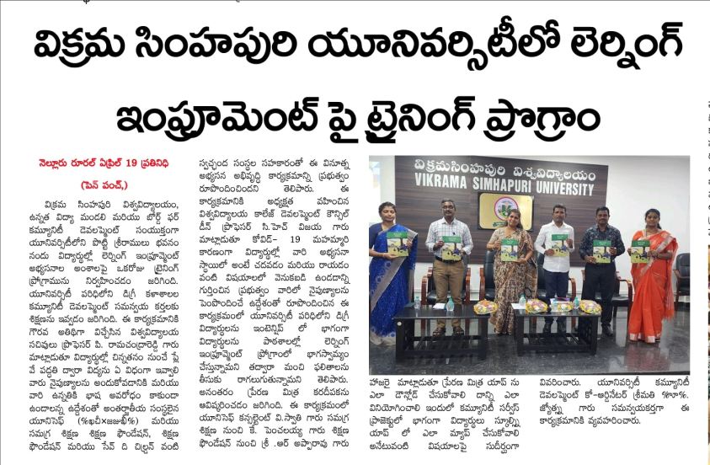

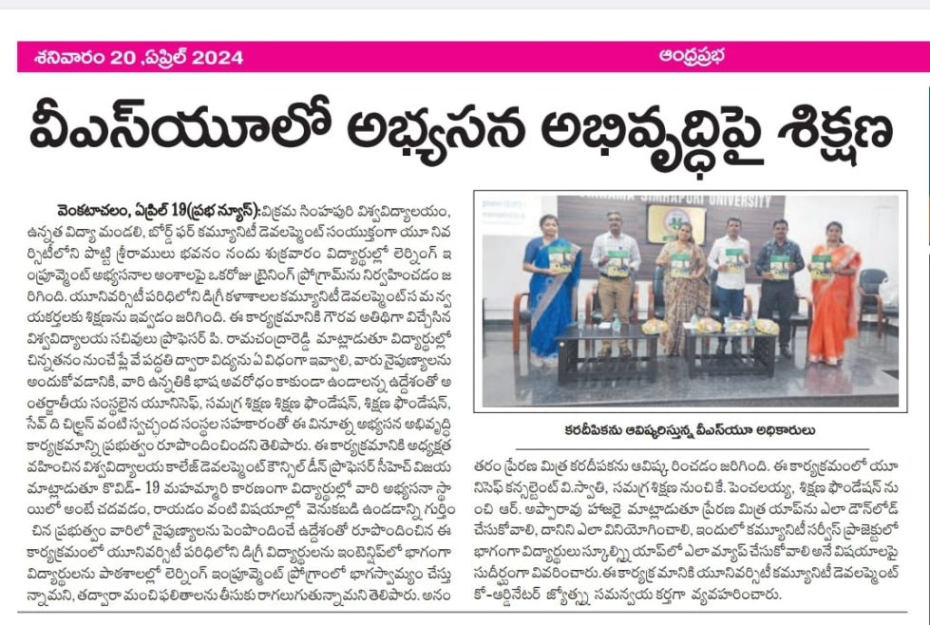

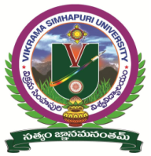
A BRIEF REPORT on
“Free Medical Camp for Students and Staff Members”
Held on 28th September 2024 at Vikrama Simhapuri University, Nellore

Higher Education Department, Government of Andhra Pradesh has issued a G.O.Rt.No.132 to conduct academic activities along with additional activities for the Academic Year 2024-25.
In this regard, the Community Development Wing (BCDE) of Vikrama Simhapuri University, Nellore in association with Narayana Medical College, organized a Free Medical Camp on 28th September 2024 at VS University Campus, Nellore. The camp aimed to promote health awareness and provide healthcare services with the goal of providing free health check-ups to students and staff of the University.
The medical camp inaugurated by Hon’ble Vice Chancellor, Prof.S.Vijaya Bhaskara Rao, V.S University, Nellore. The Hon’ble Vice Chancellor delivered an inspiring speech, emphasizing the importance of health awareness, preventive care and the university's commitment to promoting wellness. Hon’ble Vice Chancellor encouraged everyone to prioritize their health and well-being and highlighted the university's efforts to provide quality healthcare services and promote healthy habits among students and staff members.
There are 160 students and faculty members (Teaching & Non- Teaching) utilized the free medical services. Specialist doctors from Narayana College & Hospital, Nellore, provided consultations free tests like Blood pressure, Blood sugar, Eye Checkups and general health check-ups…etc.
The Hon’ble Vice Chancellor, Prof.S.Vijaya Bhaskara Rao and Dr. Suneetha, Registrar, V.S. University felicitated the participate doctors & team from Narayana Medical College & Hospital, Nellore for their contributions to the camp's success.
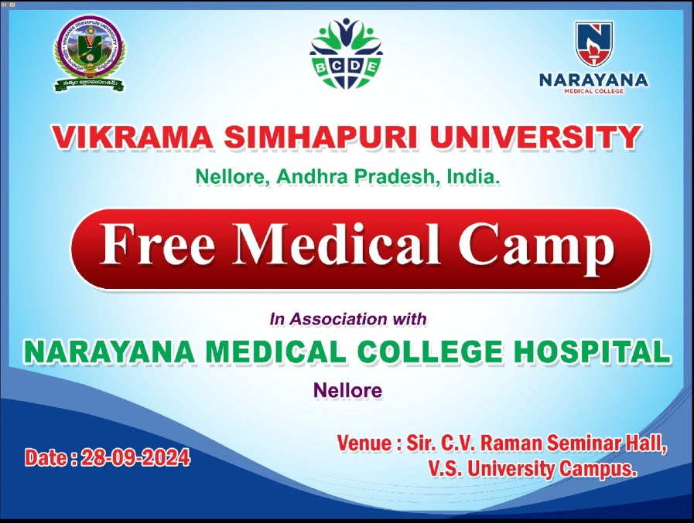

Medical Camp Inauguration By Hon’ble Vice – Chancellor Prof. S.Vijaya Bhaskar Rao
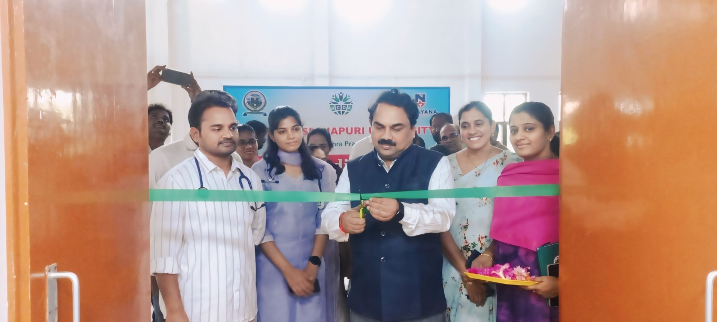
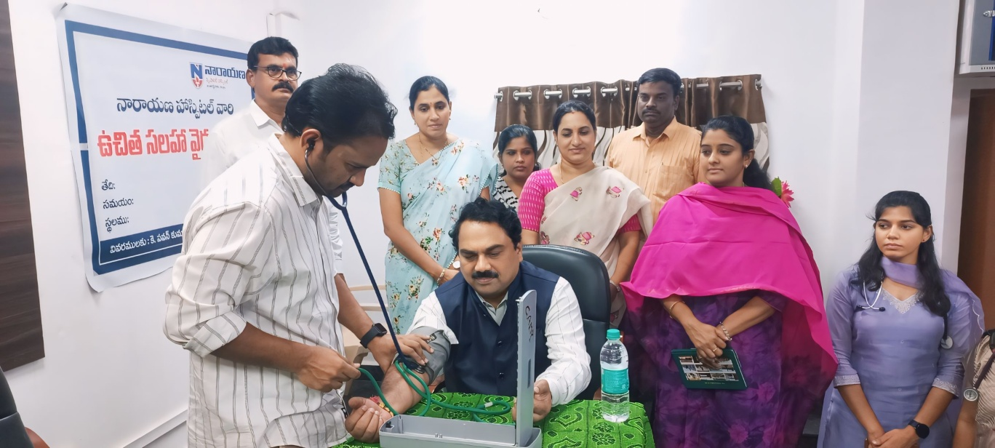
Address by Hon’ble Vice – Chancellor Prof. S.Vijaya Bhaskar Rao
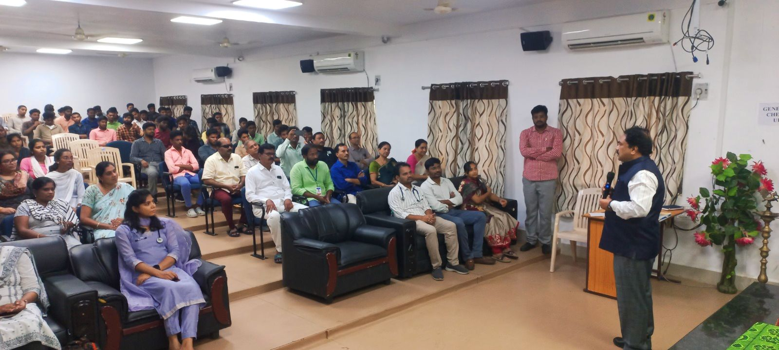

Program Photos:
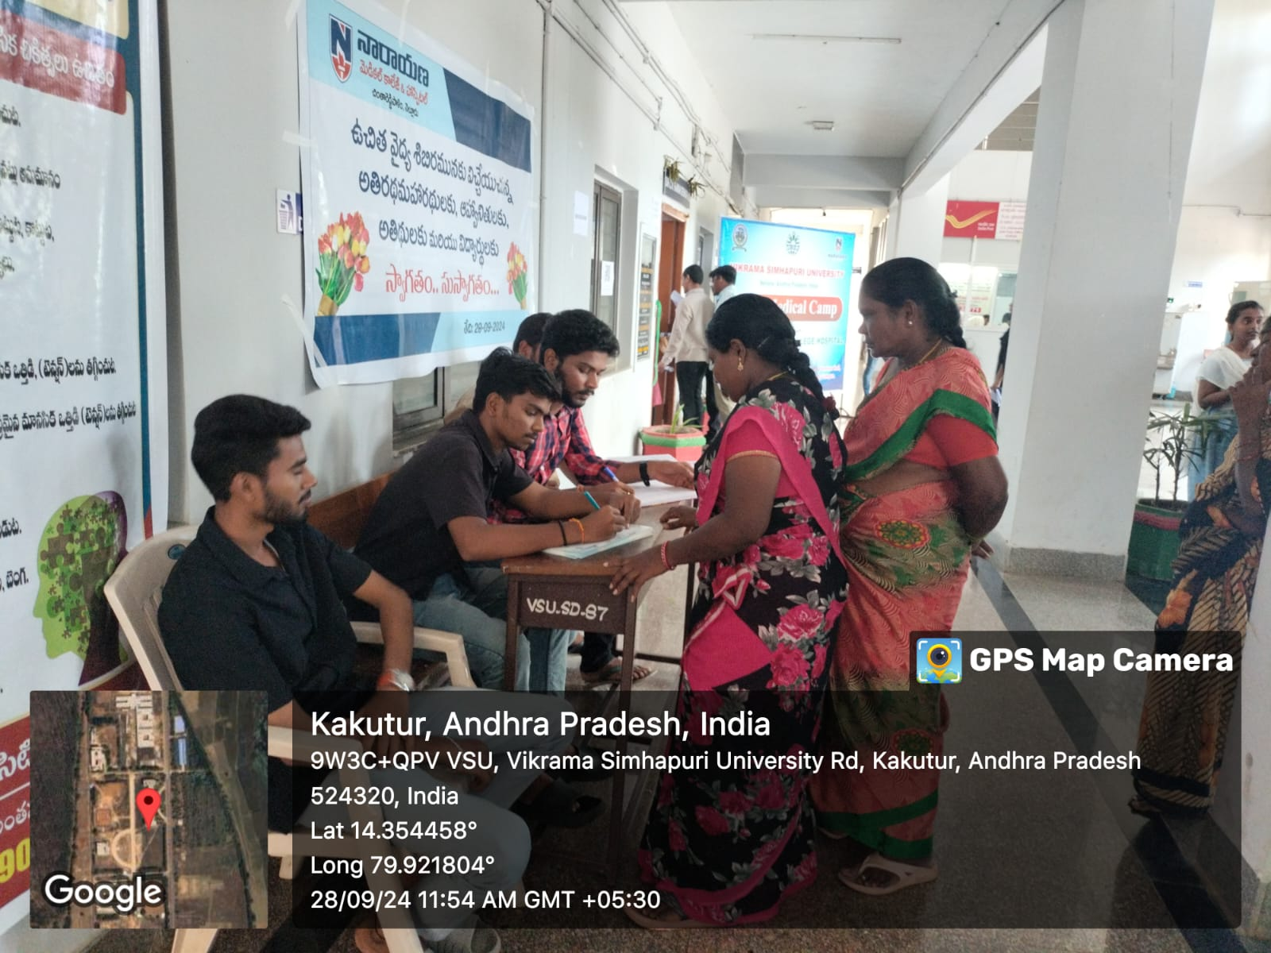
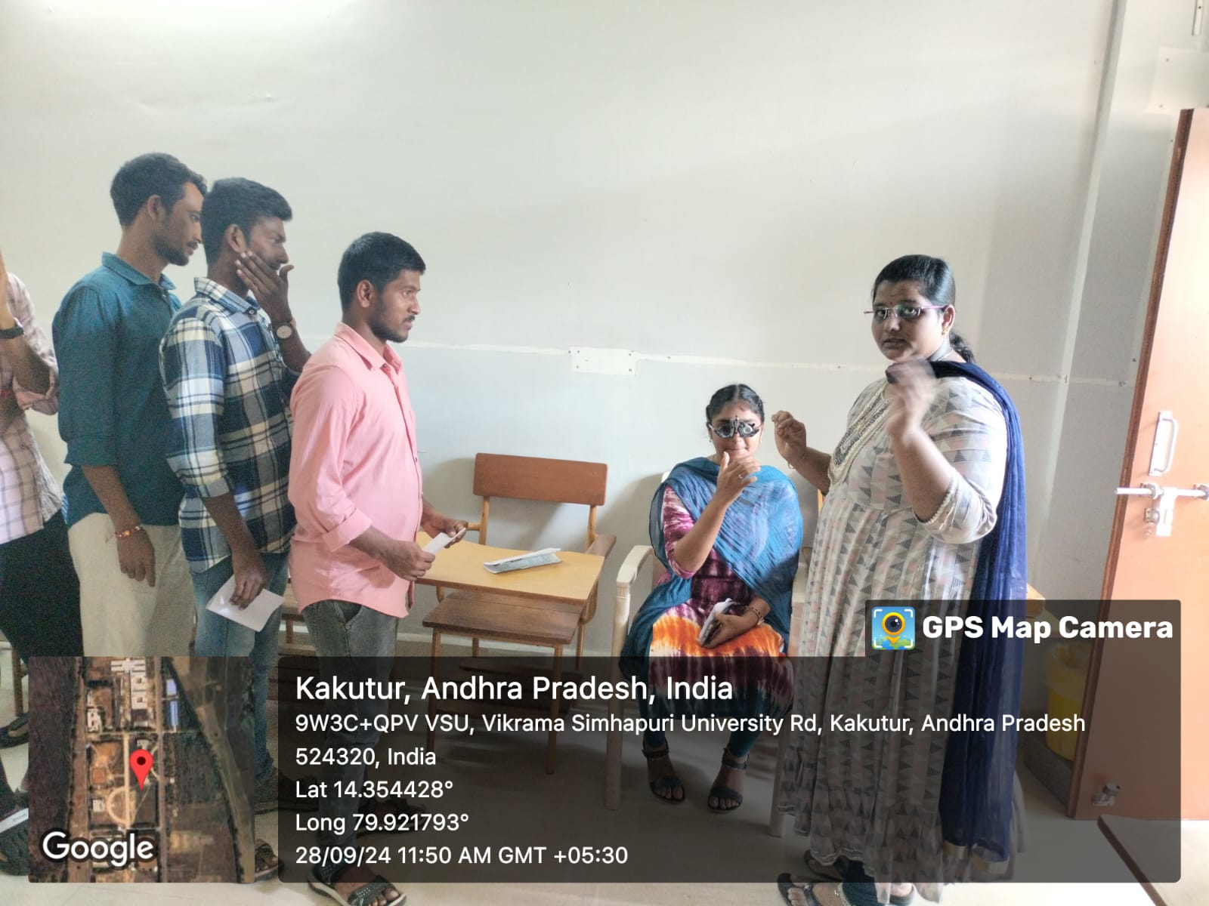
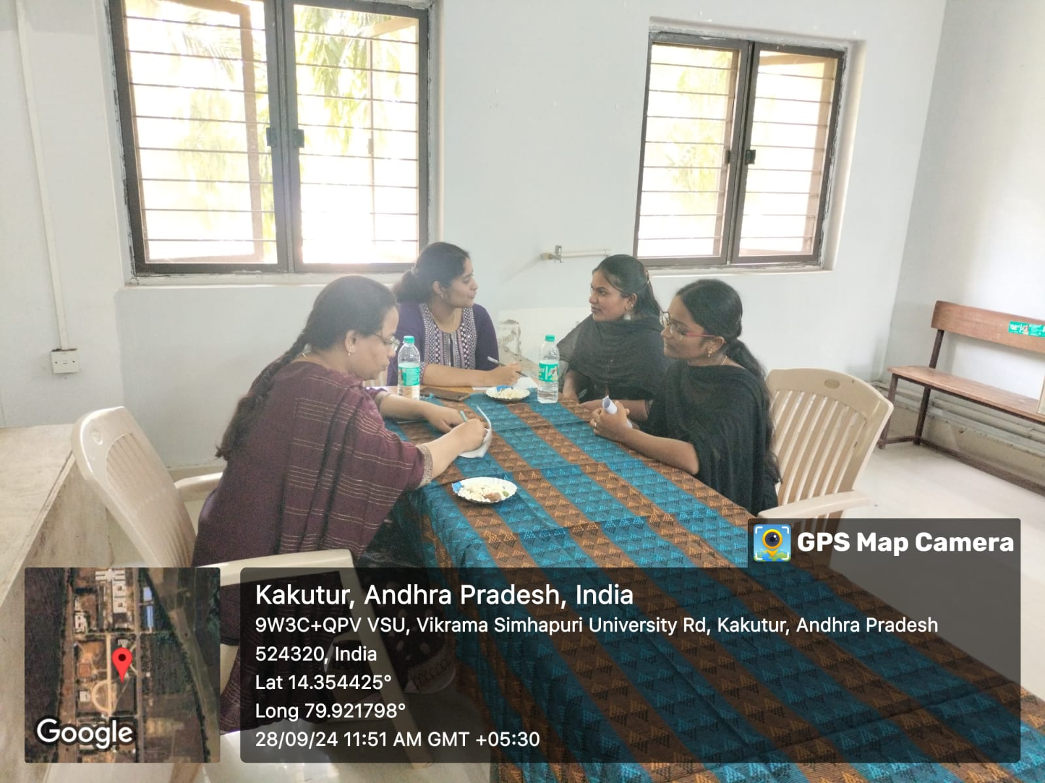

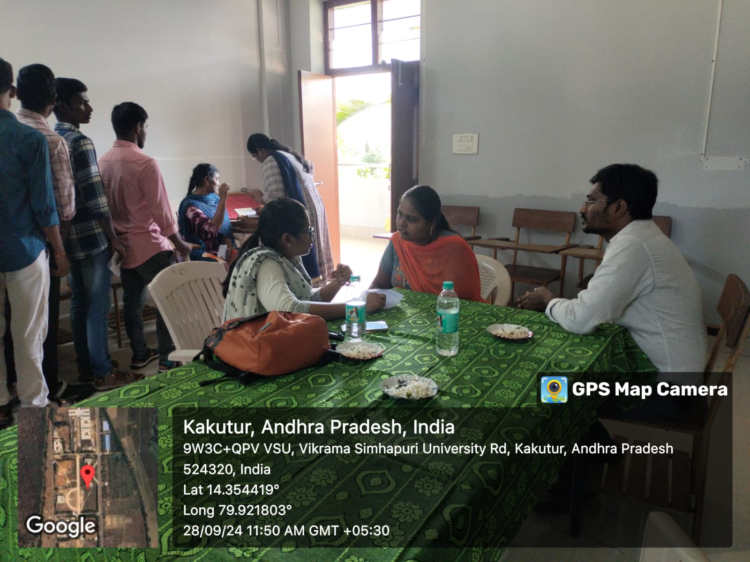

Felicitation to the Medical Team
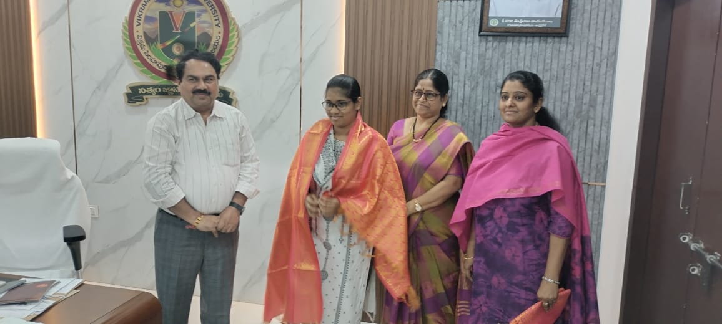
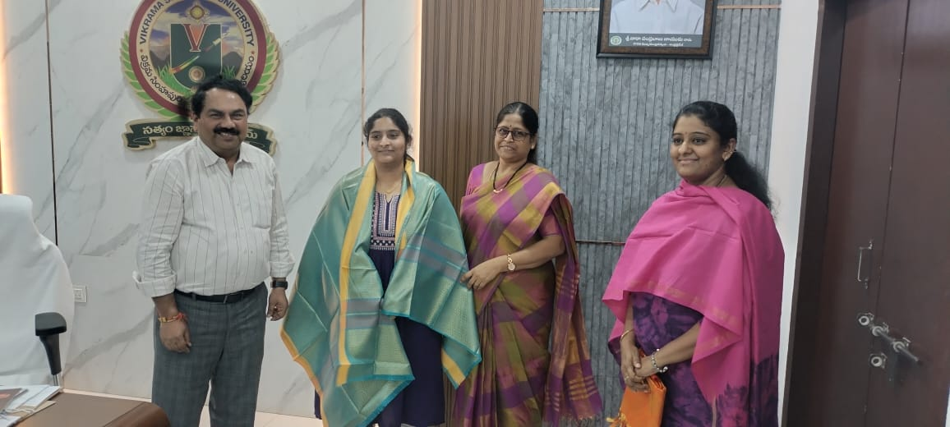

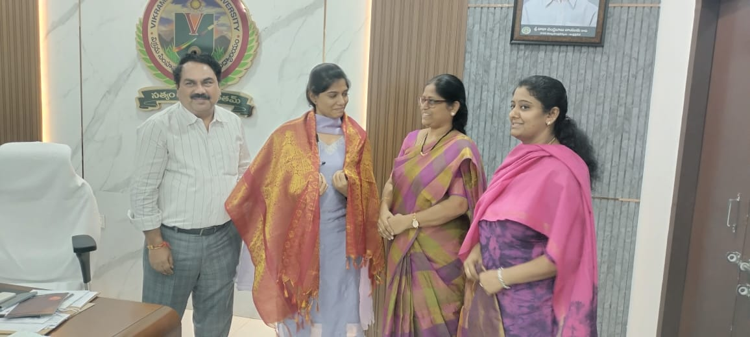

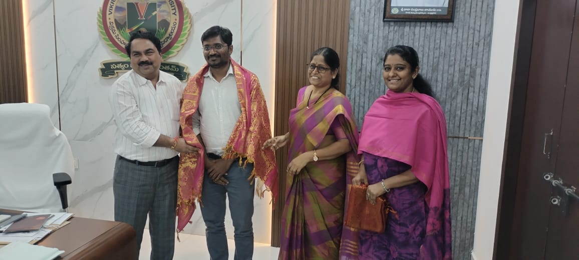
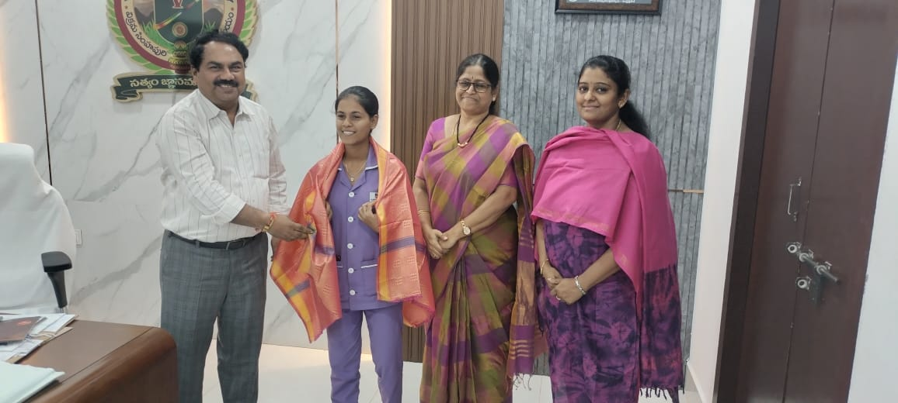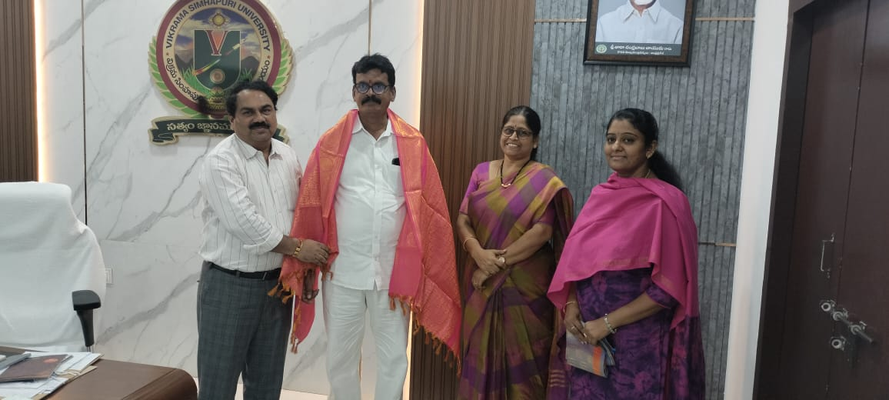

Press Clippings of the Programme